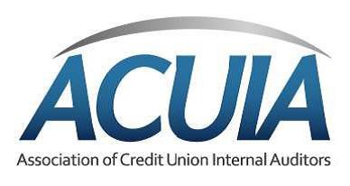
ACUIA Region 1 Agenda
Virtual Fall Meeting
Thursday October 1, 2020

9:20 – 9:30 | Opening Remarks
9:30–10:30 | QARs & QAIPs  Roger Jones, Managing Partner  Hauser Jones and Sas
10:30 – 11:00 | Break
11:00–12:00 | ERM & Audit  Dr. Randy Thompson  TCT Risk Solutions
12:00–1:30 | Break
1:30–2:30 | Control Considerations over Lending in 2020  (PPP, Regulation Compliance Considerations, Loan Forbearance/Modifications, Best Practices)  Noory Song and Daniel Lee, Senior Managers  Moss Adams
2:30 –3:00 | Break
3:00 – 4:00 | Auditing with Emotional Intelligence  Carrie Pokrefke, Audit Manager  BECU Credit Union

ACUIA Region 1 Agenda
Virtual Fall Meeting
Friday October 2, 2020

9:20 – 9:30  9:30 – 10:30 | Opening Remarks  Data Analytics  Tavish Taylor, Director of Internal Audit and Advisory Services  Hauser Jones and Sas

10:30 – 11:00  11:00 – 12:00 | Break  Raising the Value of Internal Audit  John Kaneklides & Olivia Whipple , Founders & Owners  The Audit Library
12:00 –1:30 | Break
1:30 – 2:30 | Auditing in a Remote Environment & Revised Focused Areas Given the Pandemic  Kevin Reynolds, Senior Manager  Moss Adams
2:30 – 2:45 | Closing Remarks

